**PAM Strategic Initiative -**

**Accessing Ocean Sounds to Inform Marine Species and Climate Trends**

**PAM- SI Team:**

Sofie Van Parijs, NMFS NEFSC (SI lead)

Catherine Berchok, NMFS AFSC

Jason Gedamke, NMFS S&T

Marla Holt and David Huff, NMFS NWFSC

Erin Oleson, NMFS PIFSC

Shannon Rankin- NMFS SWFSC

Melissa Soldevilla, NMFS SEFSC

Carrie Wall Bell, NOAA NCEI

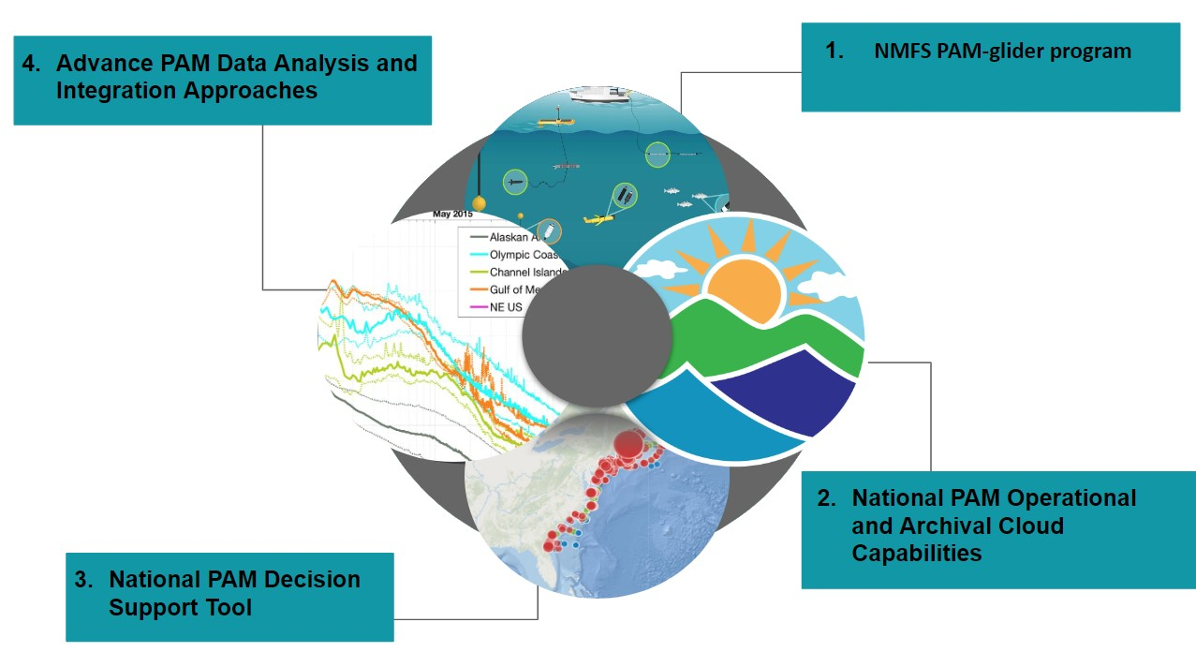

**PROJECT TASKS & KEY ACTIVITIES**

Following feedback from the Science Board the PAM-SI has revisited and clarified its priorities and proposes 4 transformational and National goal oriented projects. The PAM SI projects focus on; 1) establishing a Pacific region glider program to mirror that in the Atlantic, 2) developing National PAM Cloud capabilities to cope with exponential growth in data and processing needs, 3) expand the existing PACM decision support tool to a National level tool, and 4) streamlining analytical and data integration to remove redundancy and increase across FMC efficiencies. In doing so, we have removed the egalitarian approach and have focused our budget on 4 National level goals, each of which are achievable over a 3 year framework. In doing so we hope we have met the mark that the Science Board was looking for in implementing transformational activities that will significantly change the way in which we collect, analyze and make our data accessible for answering mission critical questions.

**Project 1. Accelerating Pacific-wide PAM-glider operations**

PAM-equipped gliders provide an autonomous solution to collecting vocal species encounter datasets that can serve NMFS assessment needs. Several studies have proven the utility of such data for examining habitat association and density estimates, though generally at a limited spatial scale. The right hardware deployed at sufficient temporal and geographic scale will provide acoustic detection and ecosystem data to inform qualitative and quantitative assessments. Such data can immediately be used to examine species occurrence and distribution in remote regions that are rarely or never surveyed using vessel-based methods. **With dedicated R&D effort, PAM-equipped gliders can augment and replace some ship-based survey efforts, informing climate assessments, including changes in range or space use, and quantitative metrics, including density.**

PAM-equipped Slocum gliders for real-time monitoring of North Atlantic right whales and other baleen whales off the Atlantic coast of the U.S. were developed through a NEFSC/WHOI collaboration over the last decade and now form part of an operational NMFS program. Those efforts currently focus primarily on monitoring low frequency cetacean species, though could be expanded to play a larger role in assessment surveys of other higher frequency cetacean species with some advancement to their acoustic data acquisition software. In partnership with the OMAO UxS Operation Center (UxSOC), PIFSC recently began testing PAM-equipped Seagliders to augment ship-based surveys across the vast Pacific Islands region. Initial surveys around the main Hawaiian Islands have provided important data on glider and high-frequency acoustic system endurance, acoustic encounter rates relative to other survey modalities, and the ability of the glider to maintain a predetermined trackline, an important consideration for systematic surveys in regions with strong currents and eddies that can force the glider off track.

Leveraging this PAM SI and the knowledge base of operational NARW glider surveys, the UxS SI, PIFSC and SWFSC will lead a **3 year effort to accelerate the transition to operations for PAM-based glider surveys**. The work will be focused in the Pacific for the duration of this IRA-funded SI because these Centers are ready to act and they are collectively responsible for the largest area under NMFS jurisdiction, have acute shortages of adequate shiptime, and must find alternative survey modalities to maintain their assessment operations. **Despite the regional focus, the goal will be to develop an R2O plan that can be adapted or applied in other regions seeking to implement PAM-equipped glider surveys to support their marine mammal assessments.** The effort includes:

1. In-water instrumentation testing of several PAM-glider systems with the goal of examining hardware and sensor choices (including WHOI DMONs) and how these choices may vary based on regional differences in assessment needs and oceanographic realities. (supported by the UxS Plankton to Whales Project and PAM SI)
2. Concurrent glider and shipboard surveys. We will deploy several PAM-equipped gliders in association with two large-scale assessment surveys- PacMAPPS west coast in 2024 and PacMAPPS Hawaii in 2025. These surveys provide an opportunity to collect glider datasets that can be compared alongside traditional cetacean survey data to guide future survey design and analytical advancements. These surveys happen infrequently, such that this is a time-sensitive opportunity to begin validation of glider-based work. (supported by the UxS SI PacMAPPS project)
3. Build capacity to sustain glider operations. PIFSC and SWFSC will increase capacity to sustain PAM-glider operations through support for glider technicians at each Center and for pilot and technician training (supported jointly by PAM SI Plankton to Whales/PacMAPPS projects and UxS SI). PAM-equipped glider services are typically not available as fee-for-service operations and partner CIs that have been supporting PIFSC R&D work to-date are not equipped to support NMFS operational use of PAM-equipped gliders. The Pacific-wide R2O plan will include considerations of operational costs for conducting PAM-glider surveys into the future.

This work is partly guided by the [Transition Plan](https://drive.google.com/file/d/1YWe750PCPZ9PbpqKfB8hZlqJb2eV5tEo/view?usp=drive_link) developed by PIFSC as part of its UxSOC- funded work and leverages the significant advancements by NEFSC and WHOI in development of PAM-equipped Slocum gliders.

**Project 2. Establishing National PAM Operational and Archival Cloud Storage solutions**

PAM acoustic recordings represent some of the largest data holdings within NMFS. The pie chart below shows the current (August 2023) volume of data at each FMC and the Ocean Acoustics program (OAP). PAM data collection is increasing exponentially each year at most FMCs and IT divisions are at a major crossroads as to how to provide the necessary infrastructure to support the growth trajectory for these data. For example, the NEFSC currently has 1300 TB (or 1.3 Petabytes) of data. Atlantic offshore wind and North Atlantic right whale mitigation, permitting and monitoring requirements rely heavily on PAM data collection. The NEFSC projected growth in PAM data over the next 3 years is for between 400 - 500TB/ year which would result in ~2.5 Petabytes by FY26. Offshore wind requirements are rapidly spreading to other NMFS regions. Therefore investment in more modern approaches and improved levels of infrastructure management of these data are urgently needed. 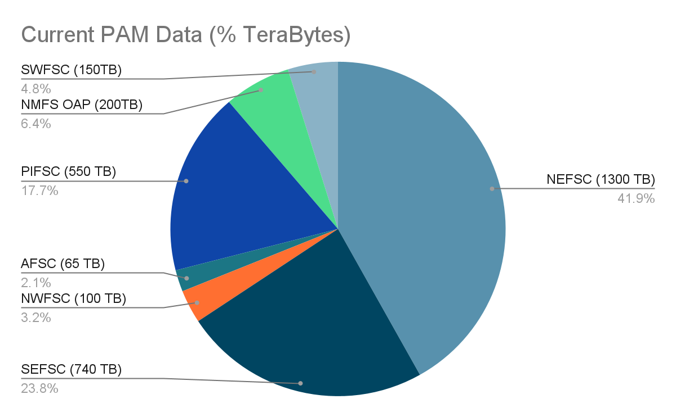

**A national PAM data management plan is needed to house *operational data* and efficiently process large quantities of data using a range of acoustic software tools in order to produce data products** **for informing climate assessments, including changes in range or space usPe of species, oceanic changes in ambient sound levels and quantitative metrics, including density.** Currently, each FMC is managing data individually with most FMCs struggling with outdated ITD capacities. NMFS OCIO is aware that the current rate of data growth can not be safely maintained and secured without introducing a modern Cloud environment approach. The major roadblock is ascertaining costs and the process by which this can be achieved. **PAM SI will work with NMFS OCIO to create the needed Cloud framework, test processing capacities with manageable data uploads during a pilot phase, while determining the true cost of a PAM Cloud solution.**

In addition, **NMFS FMCs and the OAP are required to archive their PAM data in a publicly accessible location to be compliant with PARR.** The NOAA [Passive Acoustic Data Archive at the National Centers for Environmental Information (NCEI)](https://www.ncei.noaa.gov/products/passive-acoustic-data) provides the perfect solution for this and already holds a small subset of NMFS data. The transfer of large quantities of PAM data is currently ineffective and time consuming. In order to efficiently archive PAM data **the PAM SI and NCEI will work to streamline the data transfer process and ensure that it can accept all PAM SI technology data types** (e.g. towed array, glider, drifting recorders, bottom mounted recorders).

*Archival data* storage in the Cloud is free of cost and publicly accessible but does not allow processing or other analytical functions. In contrast, *operational data* storage in the Cloud requires a yearly service level cost agreement (SLA) but allows rapid and efficient processing and adheres to NMFS’ security regulations. As a result, in collaboration with NMFS OCIO, the PAM SI have worked to define the following data modernization efforts using Cloud storage. The efforts include:

1. Developing a Cloud SLA model and structure for operational NMFS PAM data with NMFS OCIO to which the FMCs can each upload ~100/500 TB (size will be cost dependent).
2. Developing a SLA model for Cloud processing of PAM data that will be tested by each FMC to evaluate processing speed and capacity for producing relevant regional and national outputs.
3. Producing a workflow and Cloud SLA cost estimate for all PAM SI data holdings together with NMFS OCIO. This will include an agreed-upon workflow by which operational Cloud PAM data will be routinely moved to archived data storage (e.g. every 3 years), thereby freeing up operational space and reducing long term costs.
4. Improving the archival pipeline to NCEI. NCEI will work with the PAM SI to produce an efficient and streamlined data transfer mechanism.The PAM SI will aim to archive 50% (more if possible) of existing PAM data by the end of FY26 (see Table below).

| **FMC** | **Project/Data Sets** | **Year of Delivery** | **Data Type** | **Data Size** | **Data Location** |
| --- | --- | --- | --- | --- | --- |
| NEFSC | AMAPPS | FY24 | Towed Array | 30TB | Local Server |
| SWFSC | ETP (Digitize Analog) | FY24 | Towed Array | 5 TB | Analog Tape Drives |
| PIFSC | PacMAPPS- Pacific Islands | FY24 | Drifter, Towed Array | 100 TB | Local server |
| SEFSC | Rice’s whale Vessel Surveys | FY25 | Sonobuoy | 3TB | External drives |
| SEFSC | Rice’s whale moorings | FY26 | Bottom Mounted | 100 TB | Local Server |
| PIFSC | Pacific Islands Passive Acoustic Network | FY25 | Bottom Mounted | 250 TB | Local server |
| SWFSC | PacMAPPs - West Coast | FY25 | Drifter/Glider | 30 TB | Local Server |
| AFSC | All datasets | FY25 | Bottom Mounted | 65TB | Local NAS and External drives |
| NEFSC | Southern New England Wind Energy Area | FY26 | Bottom Mounted | 300TB | Local Server |
| OAP | NRS | FY26 | Bottom Mounted | 30TB | Local server |
| NWFSC | Outer Coast (Huff)  PNW coastal recorder 2006-2011  PODS | FY26 | Bottom Mounted  Bottom Mounted  Towed Array | 30TB  10TB  5 TB | Local Server  And External drives |

**Project 3. Developing a National PAM Decision Support Tool**

**Ready access to decision support tools using PAM data products are essential** **for allowing NOAA scientists, managers, academia, industry, NGO’s and other stakeholders to make informed decisions with regards to regulating anthropogenic activities and understanding long term data trends.** The [Passive Acoustic Cetacean Map | NOAA NEFSC](https://apps-nefsc.fisheries.noaa.gov/pacm/#/) (PACM) is currently focused on providing Atlantic PAM detections for 11 cetacean species. This tool is widely used by stakeholders in a wide range of management decisions ranging from permitting of aquaculture farms or wind turbines, development of offshore wind mitigation and monitoring guidelines, standards and operational plans. In addition, scientific researchers contribute their PAM detection data to help increase the capacity of PACM to inform long term climatic or anthropogenic changes in species distributions and occurrence. As a result PACM houses cetacean detection data from over 40 institutions and collaborators. Additionally NMFS and BOEM are requiring all PAM detection data collected by offshore wind energy companies to be uploaded into PACM. 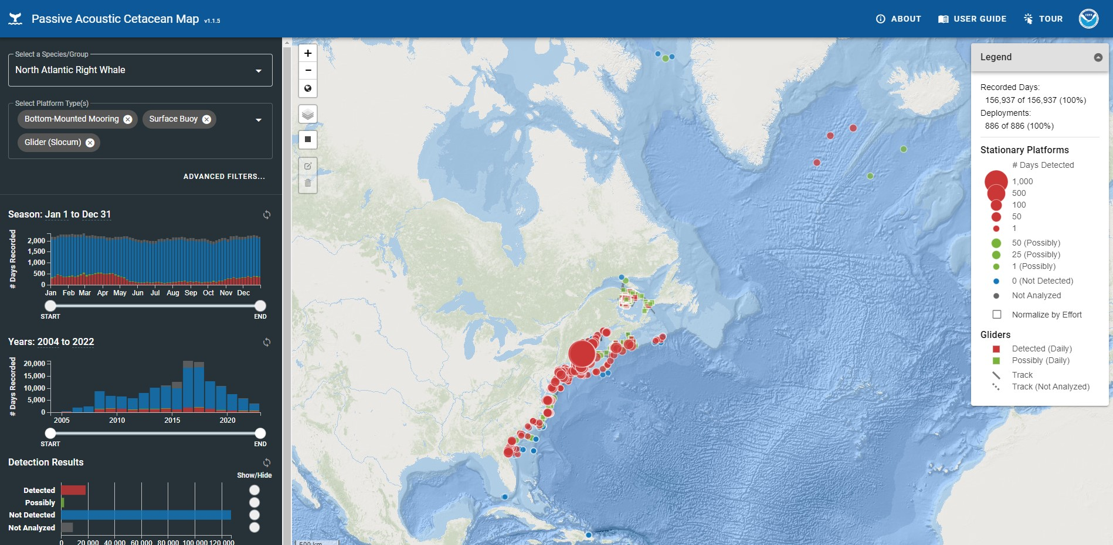

**In order for PACM to be transformed into a National product** that can not only accommodate growing NMFS data but also other NOAA line offices (ONMS, PMEL, IOOS), offshore wind industry and further collaborator data, **PACM needs to be moved into the Cloud where an underlying infrastructure database can be created to facilitate efficient data upload.** The PACM software engineer will work together with NMFS OCIO to migrate PACM to the cloud and construct a relational database allowing broader data contributions. The PAM SI will focus on adding regional historical data to PACM, while NARW IRA and BOEM IRA funds will focus on adding industry and collaborator data.

PACM is designed to be able to incorporate other analytical decision support tools. [EcoSHEDS | USGS](https://www.usgs.gov/apps/ecosheds/#/) provides a good example of what an expanded version of PACM might grow to look like. In Project 4, PAM SI will work on the further development of some of these integrative tools. One integrative data measure that is ready for PACM integration are ambient sound measurements. Species and oceanographic changes can be monitored by making baseline soundscape data comparisons with ocean temperature, salinity and other oceanographic and biological data attributes. **As part of the National PACM decision support tool, the PAM SI will analyze sound metrics across all PAM data archived at NCEI. The PACM software developer will create a framework for exploring these data metrics and PAM SI members and other stakeholders will test its effectiveness as a decision support tool.**

The PAM SI efforts will focus on:

1. Moving PACM into a Cloud environment and constructing a relational database. The PACM software developer will work with NMFS OCIO cloud architect to design the underlying database needed for PAM SI species detection data upload. FMCs will prepare and upload cetacean data products (see Table below).
2. Develop a framework for a PACM ambient noise decision support tool. OAP will analyze all archival NMFS data going to NCEI for ambient noise metrics. The PACM software developer will create an ambient noise tool that PAM SI will test and evaluate.
3. Establish a routine workflow and cost estimate for regular data ingestion. PAM SI will prioritize continued sharing of data products. Final workflow and cost estimates for further development needs and maintenance of PACM will be produced.

| **FMC** | **Cetacean Detection Data** | **Status** |
| --- | --- | --- |
| SEFSC | LISTEN GOMex | In progress |
| SWFSC | Pascal, CCES, ADRIFT | In progress |
| NOS | SanctSound data and other ONMS data | In progress |
| NEFSC | All NEFSC PAM data to date | In progress |
| OAP | All relevant NRS data | Not started |
| SWFSC | PacMAPPs West coast 2024 | Not started |
| AFSC | All datasets | Not started |
| NWFSC | PNW coastal recorder 2006-2011 dataset | Not started |
| PIFSC | Pacific Islands Passive Acoustic Network | Not started |
| SEFSC | Rice’s whale vessel surveys, moorings | Not started |

**4. Advancing National PAM Analytical and Integration Approaches**

**Synergies in PAM analytical software approaches are needed across all FMCs in order to provide National level data products.** Currently, each FMC has its own suite of analytical tools and approaches, however in many instances similar if not the same approaches are frequently used. In order to improve our analytical workflows and create an efficient Cloud processing system for operational data (Project 2), the PAM SI will hold several workshops to take stock of current analytical softwares being used and prioritize where efficiencies need to be created.

As a second step the PAM SI will **integrate PAM datasets to further their application into quantitative density or distribution models** with the intent of adding this approach to the National PACM decision support tool in due course (see Project 3). This requires 1) efficient data processing pipelines that can apply detection, classification, and localization algorithms to large datasets to extract species-specific information and 2) analytical development to account for the specific nature of passive acoustic datasets. A workshop will be held in FY25 specifically aimed at bringing together experts in the field of density estimation that can help provide advice and analytical approaches for this effort. This effort may be further advanced through partnership with the Navy’s Living Marine Resources (LMR) Program. This Program previously funded significant advancements in density and distribution modeling using visual datasets and is primed to extend that effort to acoustic data in partnership with NOAA and the PAM-SI in 2025 or 2026, creating opportunity to further operationalize the use of PAM data for the benefit of NMFS and Navy purposes.

In order to achieve these two goals PAM SI will contract 3 software programmers or quantitative modelers who will collectively work across identified FMC needs.

The PAM SI efforts will focus on:

1. Improve workflow and efficiencies across identified PAM software. Software programmers will work to identify and improve workflows across all FMCs. PAM SI will identify processing tools that can be ported to open source software and work to produce analytical approaches that can be shared across regions/species and FMCs.
2. Streamline the processing of the substantial passive acoustic data holdings. Software programmers will work to improve code structure, access to multiple computer cores and evaluate how identified software works in the Cloud environment.
3. Design integrative approaches for PAM data aimed at improving quantitative density or distribution models. PAM SI members will work with the software programmers to advance integrative tool development using data from a number of identified projects to evaluate how close we can come to producing quantitative density estimates and distribution models with PAM data.
4. Hold three planning workshops. The first will focus on efforts 1 and 2, the second on effort 3 and a final workshop will coalesce all efforts.

**Operational Products:**

1. Establishment of a **Pacific Region glider program** with expanded National applications for vocal species stock assessments and distribution modeling. *Funding levels for PAM-SI or UxS-SI may impact transition to operations.*
2. Operational workflow for **Cloud Data Storage, Processing, and Analysis** - evaluation, streamlining of software, and secure storage. *Availability and timeliness of Cloud architect support and SLA development via OCIO may impact our ability to operationalize within the 3 years.*
3. **National online PACM tool** for improved integration of PAM data for regional and national management decisions related to offshore wind, climate assessments, ESA status reviews, and other actions.
4. **Standardized Advanced PAM Data Products** integrated in streamlined cloud processing workflow for all FMCs.
5. **Archiving Cloud Data to meet PARR** - efficient archiving of key data sets with NCEI.

**Transformational Products**

1. **Accelerate national use of PAM-equipped underwater Gliders to advance alternate options for marine mammal surveys:** Develop and advance a Pacific-wide Research to Operations plan that considers existing glider platforms and their appropriate use in different environmental conditions and to address different scientific questions. Using NEFSC/PIFSC experiences, advance transition of operations to TRL 8 (PIFSC, SWFSC) and inform a national strategy to augment critical assessment surveys and reduce dependency on white ships for regular monitoring. Significant investment here could reduce our time to fully operational capacity by 10 years versus status quo pace of R&D and validation.
2. **Establish National PAM Operational and Archival Cloud Storage Solutions:** Develop an operational Cloud SLA model and structure for the large (and rapidly increasing) PAM data and improve data ingest pipeline to NCEI. This investment ensures maximum use of existing and forthcoming datasets for NMFS, efficient collaboration across regions, and other purposes. National plan will be tested and implemented regionally and will include identifying operational and long term costs. .
3. **Producing a National PAM Decision support tool (PACM):** Expand regional PACM tool to a national cloud-based platform for intuitive and interactive visualization of marine mammal seasonal presence and soundscape metrics. Automated workflow will facilitate data ingest to decrease latency of data assimilation and a user-friendly interface will allow managers and stakeholders to base decisions on historical and new data.
4. **Advance National PAM Analytical and Integration Approaches:** Improve workflow and efficiencies to streamline the processing of PAM datasets , with a focus on open source software and cloud based processing. Design integrated approaches for PAM data aimed at improving quantitative density or distribution models and providing standardized data products to meet NOAA mandates.

**PAM-SI DATA MANAGEMENT PLAN**

See [PAM-SI_DMP_20230814](https://docs.google.com/document/d/1NGQbz8X_gHfPwyKM0XB6ub6LQQjrUaNfD6Hsze_DH04/edit)